**Practical No. 7**

**String Handling**

**Program 7(a):** String operations for string length, string concatenation.

**Example:** Write a program to accept a string and find its length without using the string header file.

**Coding:**

#include<iostream.h>

#include<conio.h>

#include<stdio.h>

void main()

{

clrscr();

char a[100];

int len=0;

cout<<"Enter a string:";

gets(a);

while(a[len]!='\0')

{

len++;

}

cout<<"The length of this string is "<<len<<" characters.";

getch();

}

**Output:**

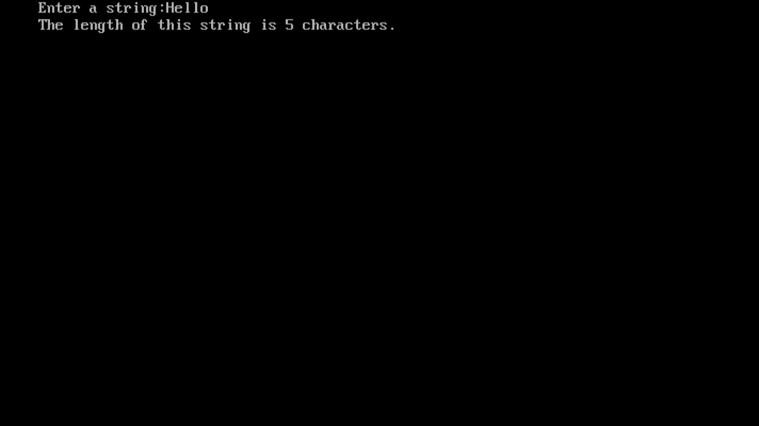

**Example:** Develop your own functions for performing following operations on strings.

* Copying one string to another.
* Adding one string to the end of another.

**Coding:**

#include<iostream.h>

#include<conio.h>

void main()

{

clrscr();

int n=0;

char a[100],b[100];

cout<<"Enter a string:";

cin>>a;

while(a[n]!='\0')

{

n++;

}

void copy (char a[100],char *p, int n);

void join (char a[100],char *p, int n, int m);

copy(a,&b[0],n);

cout<<"New string after copy is "<<b<<endl;

join(a,&b[0],n,n);

cout<<"New string after concatenation is "<<b<<endl;

getch();

}

void copy (char a[100],char *p, int n)

{

int i;

for(i=0;i<=n;i++)

{

*(p+i)=a[i];

}

}

void join (char a[100],char *p, int n, int m)

{

int i;

for(i=n;i<=m+n;i++)

{

*(p+i)=a[i-n];

}

}

**Output:**

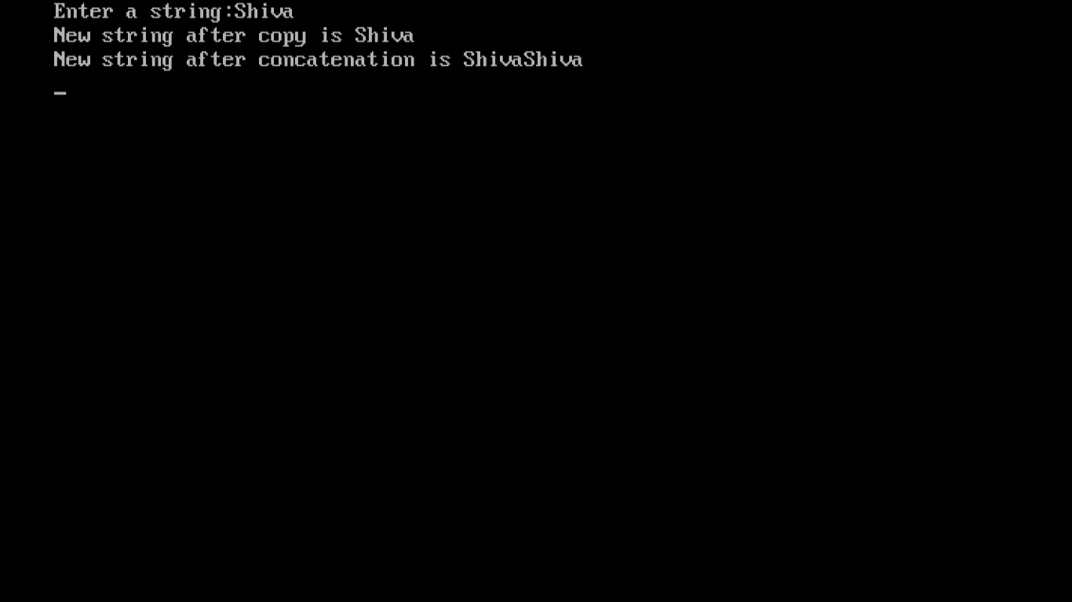

**Program 7(b):** String operations for string reverse, string comparison.

**Program:** Write a program to reverse a user entered string.

**Coding:**

#include<iostream.h>

#include<conio.h>

#include<stdio.h>

#include<string.h>

void main()

{

clrscr();

int l;

char a[100];

cout<<"Enter a string:";

gets(a);

strrev(a);

cout<<"The reverse string is :"<<a;

getch();

}

**Output:**

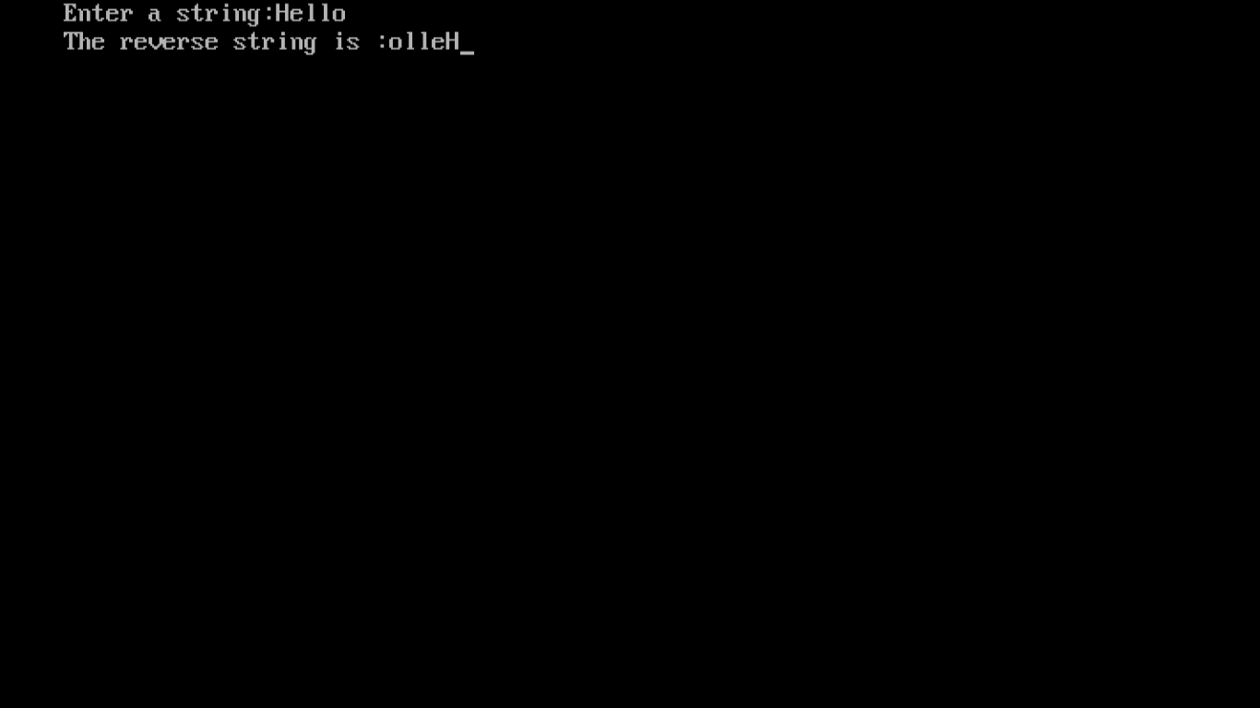

**Example:** Write a program to check whether the entered string is palindrome or not (do not use the string header file).

**Coding:**

#include <iostream.h>

#include <string.h>

#include <stdlib.h>

using namespace std;

int main(){

char string1[20];

int i, length;

int flag = 0;

cout << "Enter a string: "; cin >> string1;

length = strlen(string1);

for(i=0;i < length ;i++){

if(string1[i] != string1[length-i-1]){

flag = 1;

break;

}

}

if (flag) {

cout << string1 << " is not a palindrome" << endl;

}

else {

cout << string1 << " is a palindrome" << endl;

}

system("pause");

return 0;

}

**Output:**

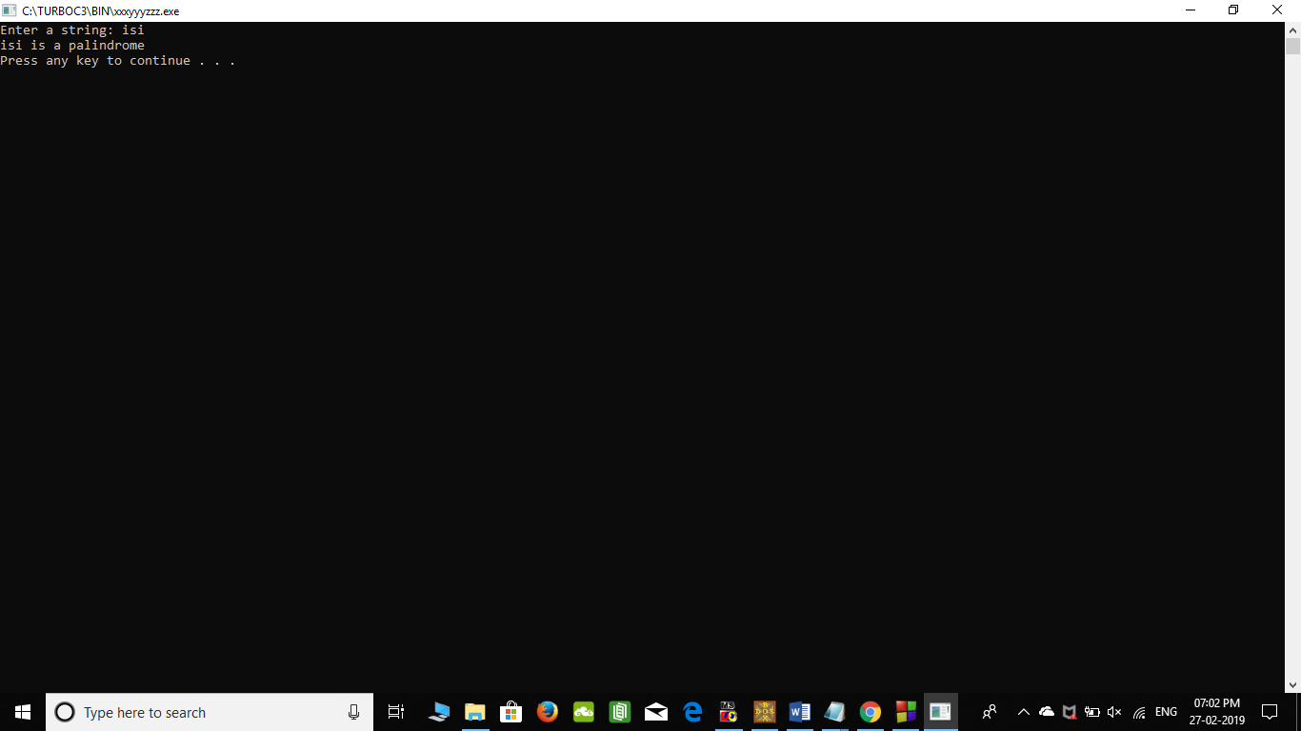

**Program 7(c):** Console formatting functions.

**Example:** Write a program to accept a string and display its length.

**Coding:**

#include<iostream.h>

#include<conio.h>

#include<stdio.h>

#include<string.h>

void main()

{

clrscr();

int l;

char a[100];

cout<<"Enter a string:";

gets(a);

l=strlen(a);

cout<<"The length of the entered string is :"<<l;

getch();

}

**Output:**

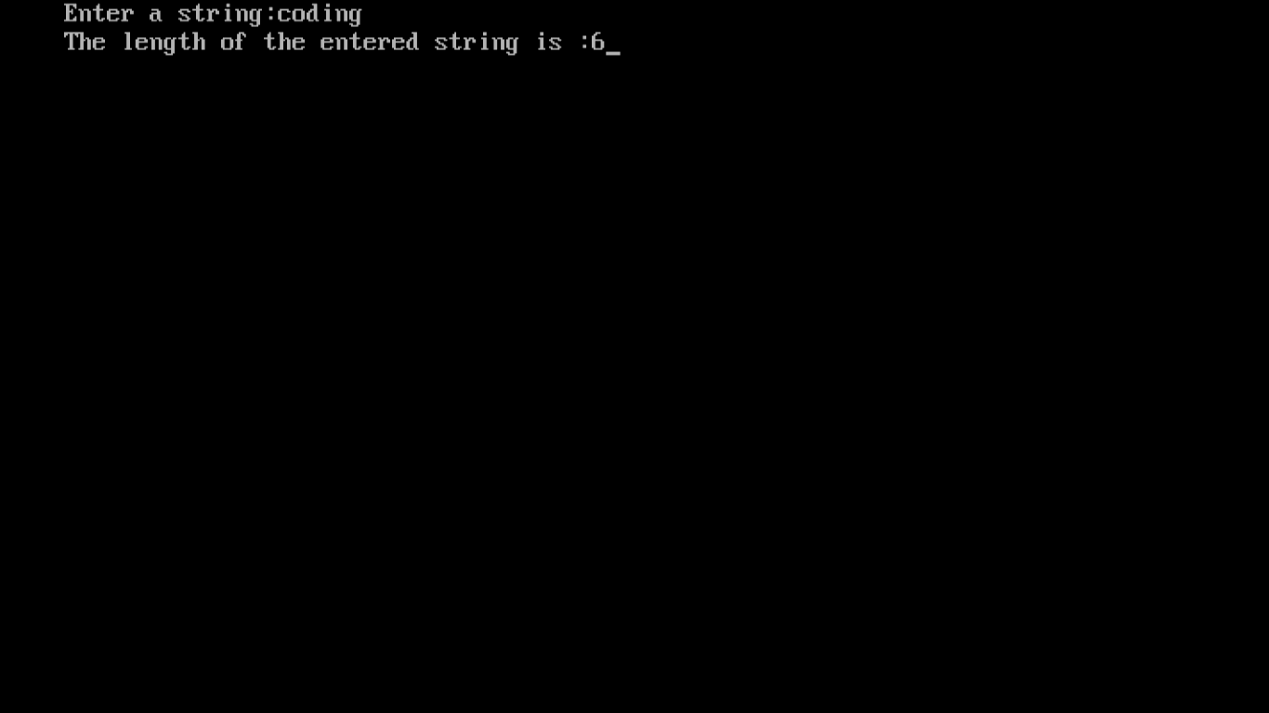

**strcpy() function**

**Example:** Write a program to accept a string, copy it into another string and display this new string.

**Coding:**

#include<iostream.h>

#include<conio.h>

#include<stdio.h>

#include<string.h>

void main()

{

clrscr();

char a[100],b[100];

cout<<"Enter a string:";

gets(a);

strcpy(b,a);

cout<<"The new string is "<<b;

getch();

}

**Output:**

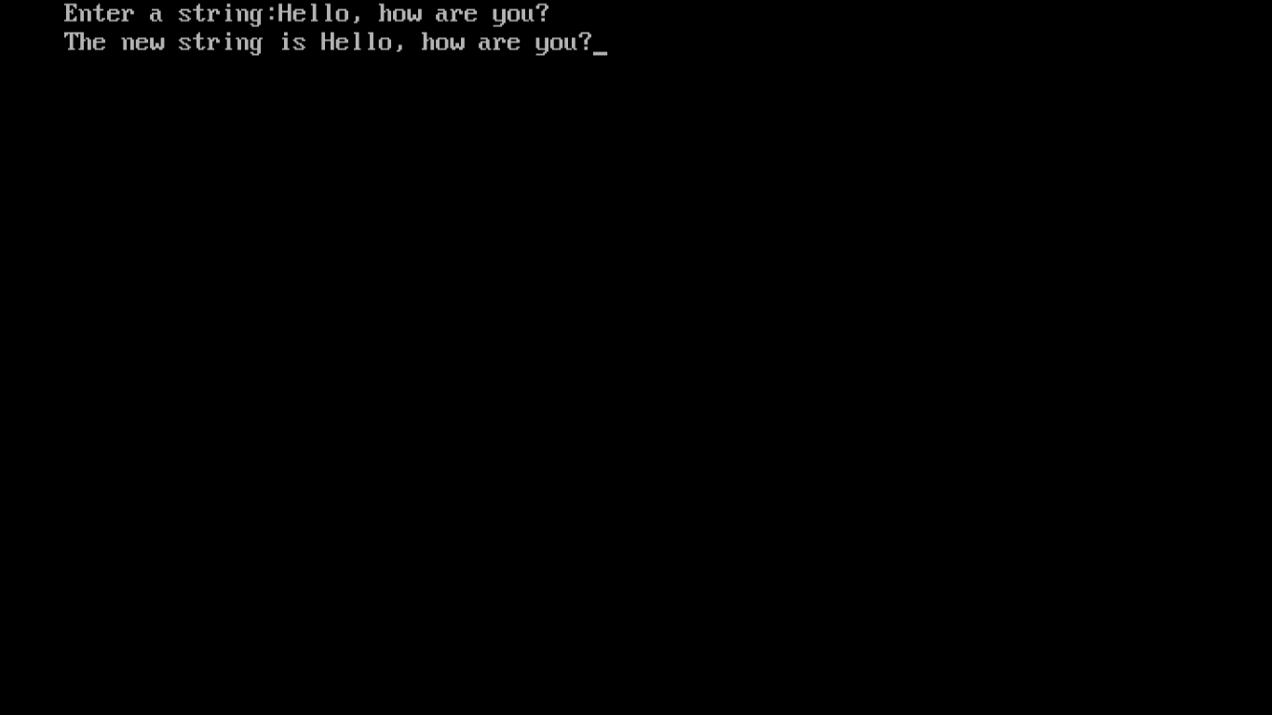

**strcmp() function**

**Example:** Write a program to accept two strings, compare them and display if they are equal or not. If they are not equal display the one which is greater.

**Coding:**

#include<iostream.h>

#include<conio.h>

#include<stdio.h>

#include<string.h>

void main()

{

clrscr();

char a[100],b[100];

cout<<"Enter two strings :\n";

gets(a);

gets(b);

strcat(a,b);

cout<<"The concatenated string is "<<a;

getch();

}

**Output:**

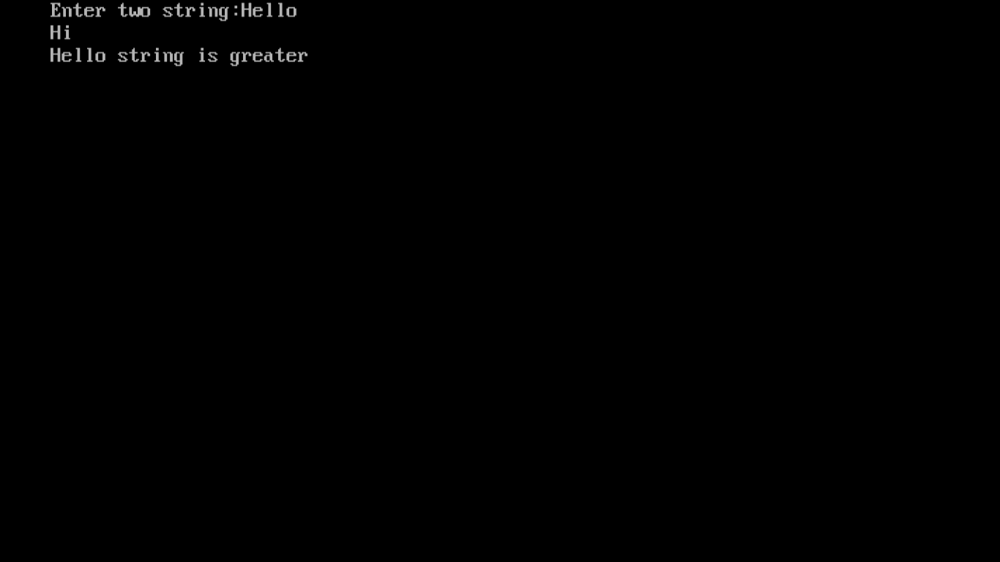

**strcat() function**

**Example:** Write a program to accept two strings, join them and display the result.

**Coding:**

**Output:**